|  |  |  |  |  |  |  |
| --- | --- | --- | --- | --- | --- | --- |
| How to promote the BizTalk Server Receive Location Name property <https://www.biztalk360.com/blog/how-to-promote-the-biztalk-server-receive-location-name-property/>    [**Sandro**](https://www.biztalk360.com/blog/author/sandro/)  [BizTalk Server](https://www.biztalk360.com/blog/category/biztalk-server/)  Jun 9, 2022  As you most likely are aware, when a document is received by a BizTalk Server adapter, the adapter creates a BizTalk message for the document. The BizTalk message contains the document that was received as well as the message context. The message context is a container for various properties that are used by BizTalk Server when processing the document. Each property in the Message Context is composed of three things, a name, a namespace, and a value.  Message context properties are added to the message context throughout the lifetime of the message as it passes through the BizTalk Server. These properties:   * Are either extracted from the message itself, for example, order id or shipment number * Or added by pipelines and adapters at the receive location, for example, transport name or receive port name   There are mainly two benefits of this context:   * The first is to provide the various components of BizTalk, and easy access to these properties, without having to parse the message * The second is to support content-based routing.   However, there are several out-of-the-box BizTalk Server context properties that are not exposed (promoted) and by that, they are not available for routing in BizTalk Server. This behavior is common to all versions of BizTalk Server, not to a specific one. You can know more about all out-of-the-box BizTalk Server context properties on this extended whitepaper:   * [Your Guide to BizTalk Message Context Properties](https://www.biztalk360.com/whitepaper/your-guide-to-biztalk-message-context-properties/)   Nevertheless, BizTalk Server allows you to extend these out-of-the-box capabilities by adding new custom property schemas to your solutions. Once after deployment, these custom context properties can be used in all components, inside Orchestrations, pipelines, or ports.  One such property is the **ReceiveLocationName** property. While **ReceiveLocationName** is available on the http://schemas.microsoft.com/BizTalk/2003/system-properties namespace and we can see it in the Context of the message inside the BizTalk Server:  BizTalk Server Receive Location  The **ReceiveLocationName** property is not promoted in the **BTS namespace**, only the **ReceivePortName** property is available. Therefore, we cannot access it inside an Orchestration or add a filter in a send port using the **BTS.ReceiveLocationName** syntax.  Nonetheless, we can access this information for example using a custom pipeline component inside a receive pipeline by using this command:  string receiveLocationName =  **pInMsg.Context.Read("ReceiveLocationName", "http://schemas.microsoft.com/BizTalk/2003/system-properties");**  To bypass this behaviour, and as I mentioned above, BizTalk Server allows you to create custom property schemas and extend the out-of-the-box promotions with more fields. So for us to easily promote the **ReceiveLocationName** property we need to create a custom Property Schema. Add a custom Property Schema As far as BizTalk Server message properties go, they can be assigned Property Schema Base types of:   * **MessageDataPropertyBase** (default) – This type means that the XPath to the property value in the message must exist. * **MessageContextPropertyBase** – opposite to the previous, this type means that the XPath may or may not exist.   Taking this information into account, what we now need to do is:   * Open a new or existing BizTalk Server Visual Studio solution and then create a property schema,  by right-clicking on the project name and selecting **Add** > **New Item…**   Add a custom Property Schema   * From the **Add New Item** window, select **BizTalk Project Items** and then **Property Schema**, and provide a name, for example, schExtendBTSProperties.xsd and click **Add**.   BizTalk Project Items   * To simply be able to access the fields on orchestration or filters in send ports, we can go ahead and change the **Namespace** of the .NET schema type to “**ExtendBTS**”.   + This is just a shortened namespace similar to the “BTS” namespace in Microsoft.BizTalk.GlobalPropertySchemas assembly.   + Note that this is not the Target Namespace, instead select the schema and go to its properties and you will find the Namespace property   Properties   * We can rename or delete the Property1 field, but what we will need in our case, is to add a property called: **ReceiveLocationName**.  |  |  |  | | --- | --- | --- | | **Property Name** | **Date Type** | **Property Schema Base** | | ReceiveLocationName | xs:string | MessageContextPropertyBase |   **Note**: A **MessageContextPropertyBase**property means that the XPath may or may not exist.  biztalk receive location   * Compile the project and deploy it.   Now that we have the schema, we just need to create a Custom Pipeline component and a custom receive pipeline to promote this property to the context of the message Create a custom Pipeline Component and custom receive Pipeline To actually promote the properties to the context of the message, we need to create a custom pipeline component and a custom receive pipeline to do the trick.  The custom pipeline is quite simple, we just need two lines of code:  string rlocationname = (string)pInMsg.Context.Read("ReceiveLocationName",  "http://schemas.microsoft.com/BizTalk/2003/system-properties");  The above line reads the receive location name that was executed in runtime. And this line below will promote the value to the field we create earlier:  pInMsg.Context.Promote("ReceiveLocationName", "<target-namespace-schema-created-above>", rlocationname);  On the pipeline, we just need to drag the component we create for example to the Decode component:  biztalk receive location  You can find a sample of the custom component and pipeline here: |

**Receive Location Name Property Promotion Pipeline Component**

<https://blog.sandro-pereira.com/2022/03/23/receive-location-name-property-promotion-pipeline-component/>

**Receive Location Name Property Promotion Pipeline Component** is a simple pipeline component to promote the Receive Location Name (**ReceiveLocationName**) property to the context of the message. Several BizTalk Server context properties are not promoted by default with BizTalk Server, which means that they are not available for routing.

One such property is the **ReceiveLocationName** property. While the **ReceivePortName** property is available in the **BTS namespace**, the ReceiveLocationName property is not promoted. It cannot be used for routing nor access it from inside an orchestration.

My team and I kept that behavior creates this project as a proof-of-concept to explain how you can promote properties to the context of the message.

**Create a Property schema**

To promote properties to the context of the message, we will need a Property Schema with these properties. In our case, we will add only one property called: **ReceiveLocationName**.

|  |  |  |
| --- | --- | --- |
| **Property Name** | **Date Type** | **Property Schema Base** |
| ReceiveLocationName | xs:string | MessageContextPropertyBase |

**Note**: A **MessageContextPropertyBase**property means that the XPath may or may not exist.

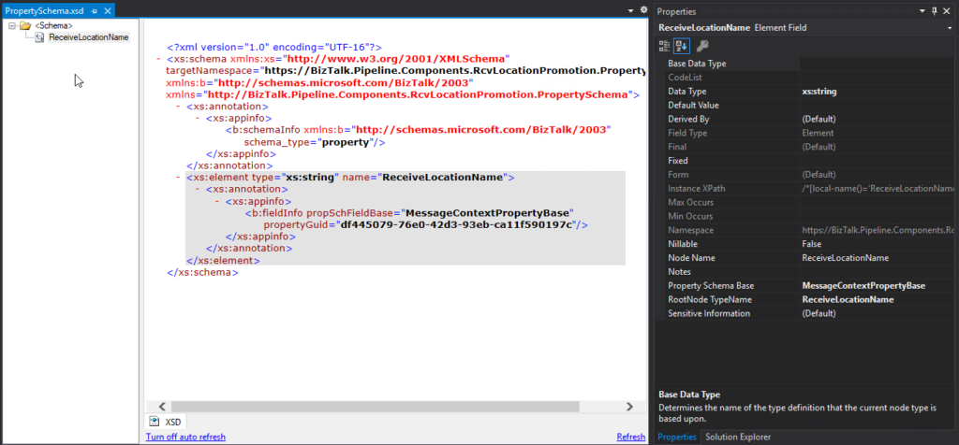

### Create a Pipeline Component

To actually promote the properties to the context of the message, we need to create a pipeline component to do the trick.

|  |
| --- |
| **string** rlocationname = (**string**)pInMsg.Context.Read("ReceiveLocationName", "<http://schemas.microsoft.com/BizTalk/2003/system-properties>");  pInMsg.Context.Promote("ReceiveLocationName", "[https://BizTalk.Pipeline.Components.RcvLocationPromotion.PropertySchema](https://biztalk.pipeline.components.rcvlocationpromotion.propertyschema/)", rlocationname); |

**How to use it**

Once you deploy the property schema and a receive pipeline component containing the Receive Location Name Property Promotion Pipeline Component, you can start to apply Content-based routing using the Receive Location Name.

